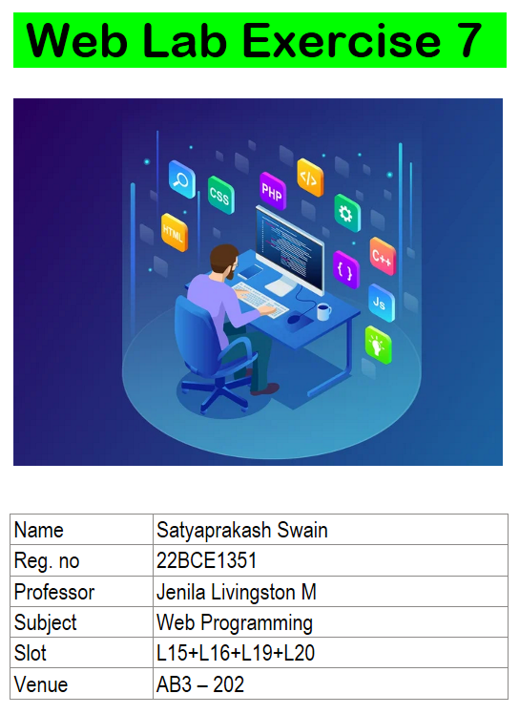

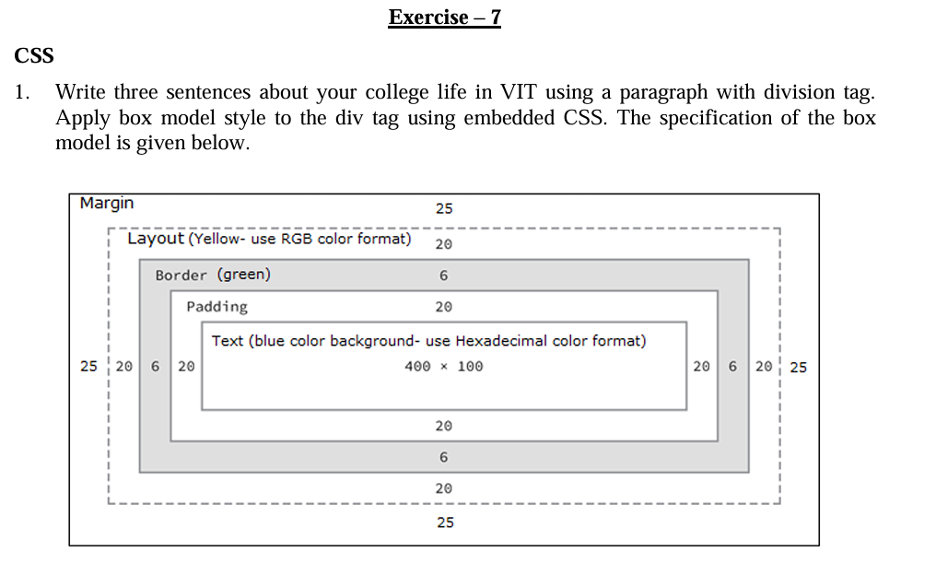

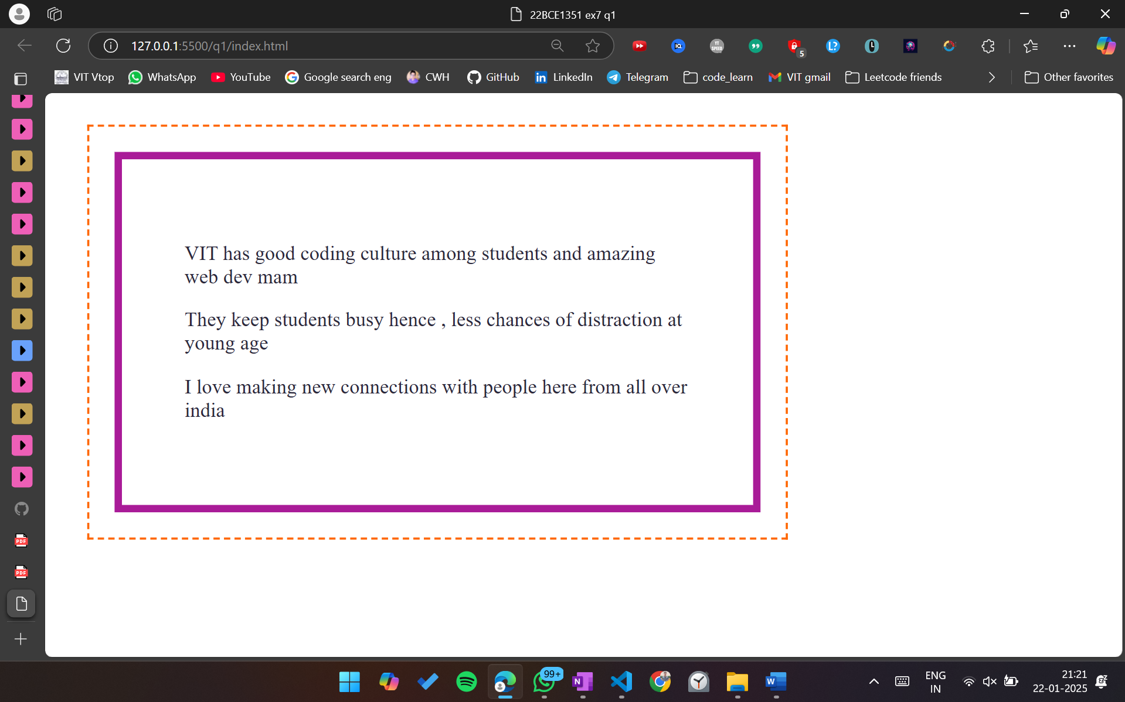

<!DOCTYPE html>

<html lang="en">

<head>

    <meta charset="UTF-8">

    <meta name="viewport" content="width=device-width, initial-scale=1.0">

    <title>22BCE1351 ex7 q1</title>

    <style>

        .outer{

            margin: 25px;

            border: 2px dashed rgb(255, 102, 0);

            width: fit-content;

        }

        .inner{

            /\* height: 100px; \*/

            width: 400px;

            color: #2c293c;

            padding: 50px;

            border: 6px solid rgb(169, 27, 152);

            margin: 20px;

        }

    </style>

</head>

<body>

    <div class  = "outer">

        <div class = "inner">

            <p>VIT has good coding culture among students and amazing web dev mam</p>

            <p>They keep students busy hence , less chances of distraction at young age</p>

            <p>I love making new connections with people here from all over india</p>

        </div>

    </div>

</body>

</html>

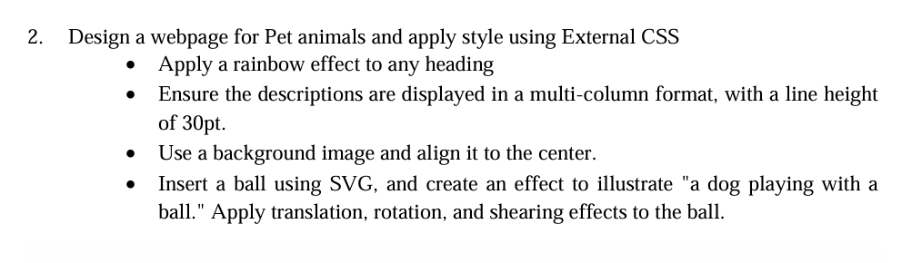

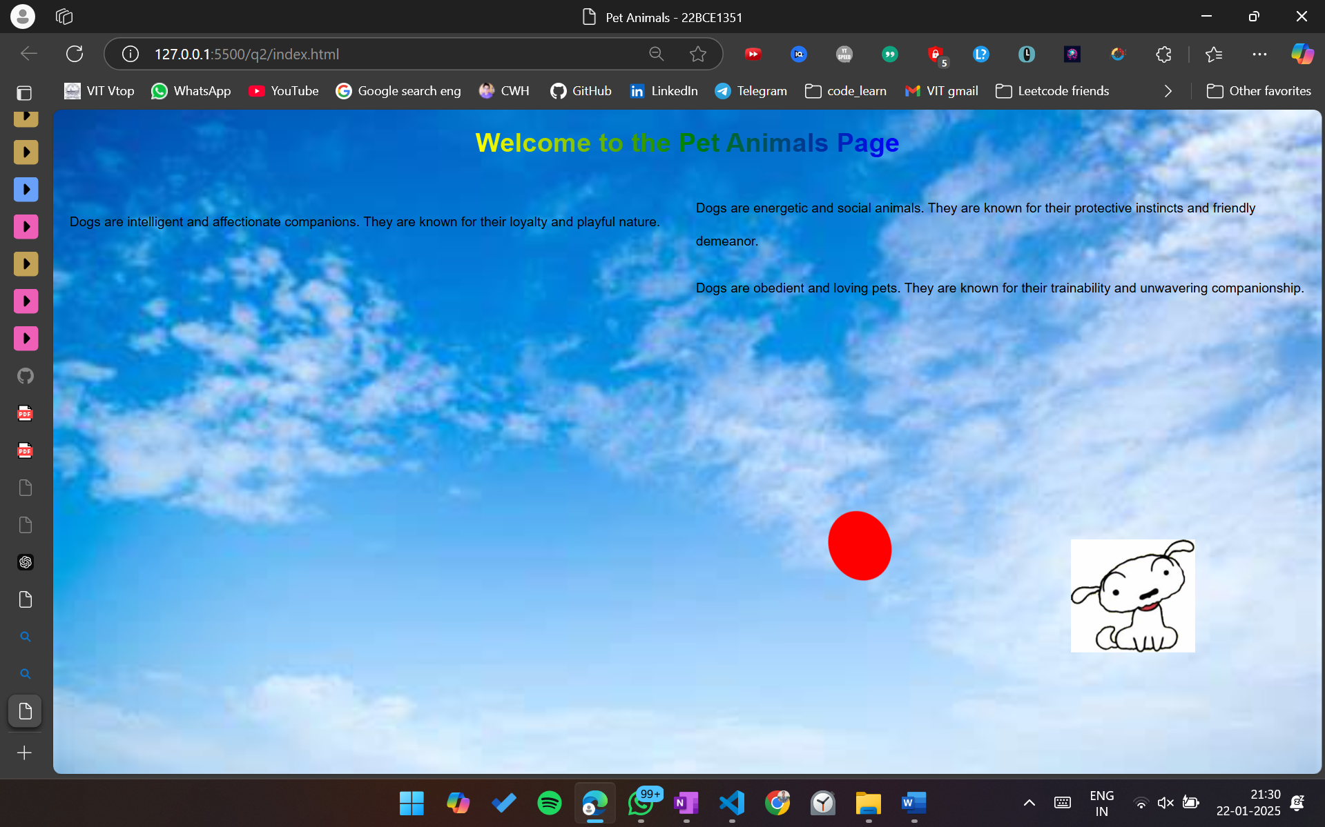

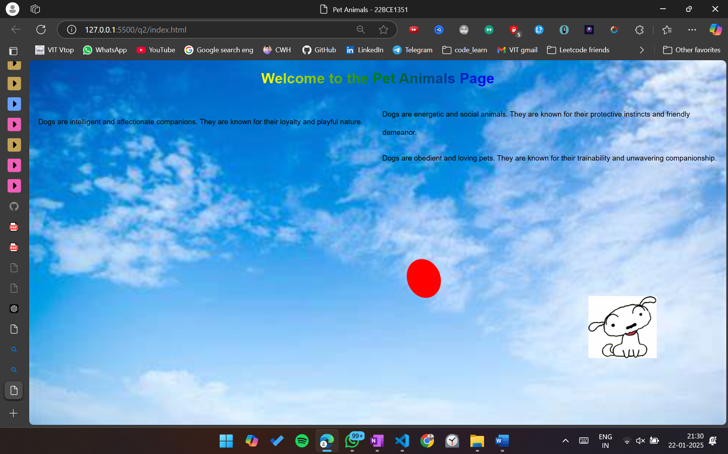

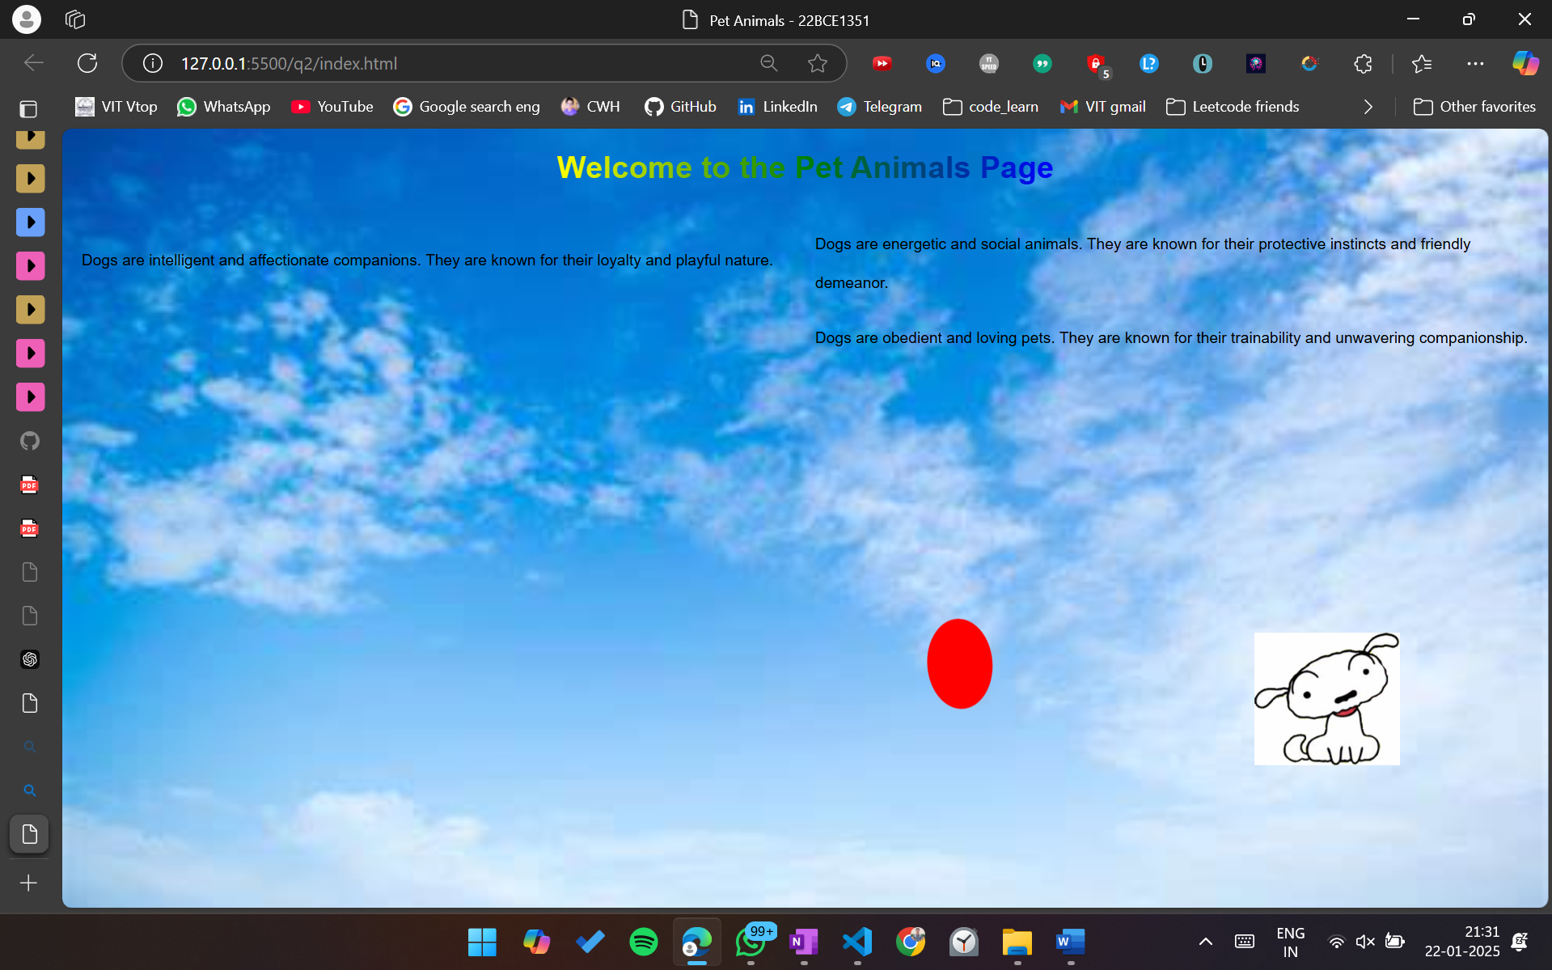

Html

<!DOCTYPE html>

<html lang="en">

<head>

    <meta charset="UTF-8">

    <meta name="viewport" content="width=device-width, initial-scale=1.0">

    <title>Pet Animals - 22BCE1351</title>

    <link rel="stylesheet" href="styles.css">

</head>

<body>

    <h1 class="rainbow">Welcome to the Pet Animals Page</h1>

    <div class="description">

        <p>Dogs are intelligent and affectionate companions. They are known for their loyalty and playful nature.</p>

        <p>Dogs are energetic and social animals. They are known for their protective instincts and friendly demeanor.</p>

        <p>Dogs are obedient and loving pets. They are known for their trainability and unwavering companionship.</p>

    </div>

    <div class="play-area">

        <svg id="ball" width="100" height="100" viewBox="0 0 100 100">

            <circle cx="50" cy="50" r="40" fill="red" />

        </svg>

        <img src="images.jpg" alt="Dog" class="dog">

    </div>

    <script src="script.js"></script>

</body>

</html>

css

Cssbody {

  font-family: Arial, sans-serif;

  background-image: url('background.jpg');

  background-size: cover;

  background-position: center;

  margin: 0;

  padding: 0;

}

.rainbow {

  text-align: center;

  font-size: 2em;

  background: linear-gradient(to right, red, orange, yellow, green, blue, indigo, violet);

  -webkit-background-clip: text;

  color: transparent;

}

.description {

  column-count: 2;

  column-gap: 20px;

  line-height: 30pt;

  padding: 20px;

}

.play-area {

  position: relative;

  width: 100%;

  height: 400px;

  display: flex;

  justify-content: center;

  align-items: center;

}

#ball {

  position: absolute;

  top: 50%;

  left: 50%;

  transform: translate(-50%, -50%);

}

.dog {

  position: absolute;

  bottom: 0;

  right: 10%;

  width: 150px;

}

Js

document.addEventListener("DOMContentLoaded", function() {

    const ball = document.getElementById("ball");

    function animateBall() {

        ball.animate([

            { transform: 'translate(0, 0) rotate(0deg) skew(0deg, 0deg)' },

            { transform: 'translate(100px, -50px) rotate(45deg) skew(10deg, 10deg)' },

            { transform: 'translate(200px, 0) rotate(90deg) skew(0deg, 0deg)' },

            { transform: 'translate(100px, 50px) rotate(135deg) skew(-10deg, -10deg)' },

            { transform: 'translate(0, 0) rotate(180deg) skew(0deg, 0deg)' }

        ], {

            duration: 3000,

            iterations: Infinity

        });

    }

    animateBall();

});

